Proposed Products

- leverage on the community. A Housing project mainly can be seen as a community project, with potential purchasers or existing community there acting as a social groups, which will collectively contribute to the design, layout to the ultimate product – the house itself.

- Combination of flickr, simcity, facebook, google sketch

Sketch and Design the basic

- to assist the amateur but more willing user, the website will also provide tools similar to that of Google Sketch (light version), that allow user to do simple sketching and save their design for others to review.
- With this wizard tool, User would thus able to extend their idea into a design that can be commented and shared in the community.

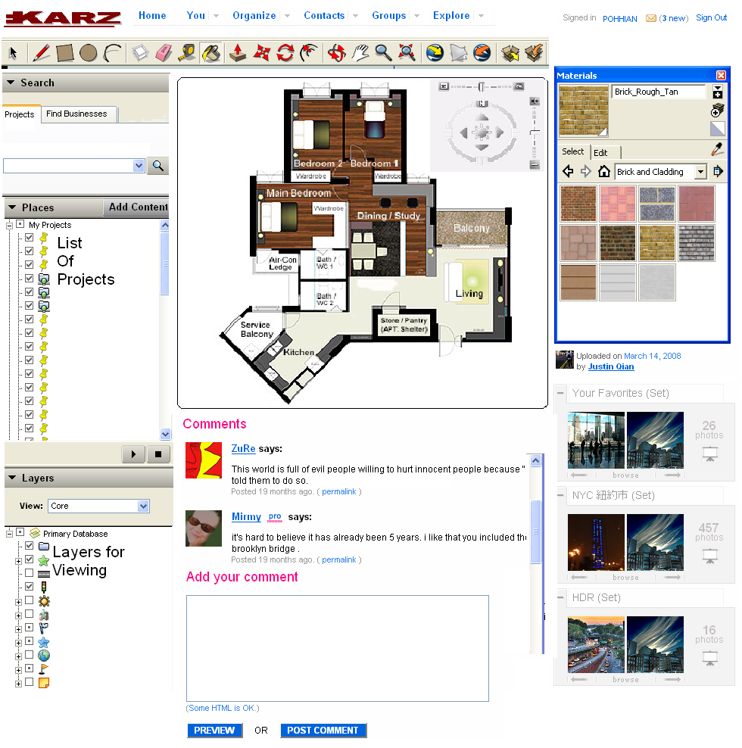

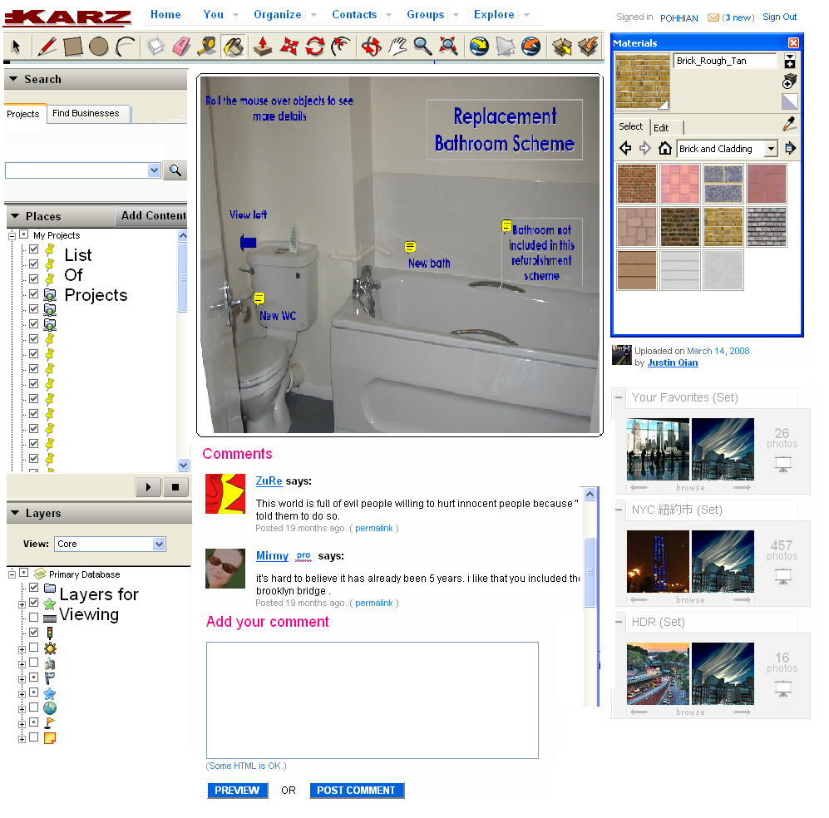

This website can be used by Property Developer to show case their upcoming project. User should be able to post comments and collectively the developers would know if the project receive warmth welcomed by the existing community, and appear attractive to the would be buyers/investors.

